Burundi

## Freedom House political status

The data set shows the Freedom House political scores and status of the country each year.

## # A tibble: 19 x 5  
## country iso3c date mean status   
## <chr> <chr> <dbl> <dbl> <chr>   
## 1 Burundi BDI 1996 7 Not Free   
## 2 Burundi BDI 1998 6.5 Not Free   
## 3 Burundi BDI 2000 6 Not Free   
## 4 Burundi BDI 2002 5.5 Not Free   
## 5 Burundi BDI 2003 5 Partly Free  
## 6 Burundi BDI 2004 5 Partly Free  
## 7 Burundi BDI 2005 4 Partly Free  
## 8 Burundi BDI 2006 4.5 Partly Free  
## 9 Burundi BDI 2007 4.5 Partly Free  
## 10 Burundi BDI 2008 4.5 Partly Free  
## 11 Burundi BDI 2009 4.5 Partly Free  
## 12 Burundi BDI 2010 5 Partly Free  
## 13 Burundi BDI 2011 5 Partly Free  
## 14 Burundi BDI 2012 5 Partly Free  
## 15 Burundi BDI 2013 5 Partly Free  
## 16 Burundi BDI 2014 5.5 Not Free   
## 17 Burundi BDI 2015 6.5 Not Free   
## 18 Burundi BDI 2016 6.5 Not Free   
## 19 Burundi BDI 2017 6.5 Not Free

## Freedom House classification of political change

The data set shows the GDP growth and the ecomic growth classification of the country each year.

## # A tibble: 19 x 4  
## country iso3c date politicalChangeFH  
## <chr> <chr> <dbl> <chr>   
## 1 Burundi BDI 1996 no change   
## 2 Burundi BDI 1998 democratization   
## 3 Burundi BDI 2000 no change   
## 4 Burundi BDI 2002 democratization   
## 5 Burundi BDI 2003 democratization   
## 6 Burundi BDI 2004 no change   
## 7 Burundi BDI 2005 democratization   
## 8 Burundi BDI 2006 autocratization   
## 9 Burundi BDI 2007 no change   
## 10 Burundi BDI 2008 no change   
## 11 Burundi BDI 2009 no change   
## 12 Burundi BDI 2010 autocratization   
## 13 Burundi BDI 2011 no change   
## 14 Burundi BDI 2012 no change   
## 15 Burundi BDI 2013 no change   
## 16 Burundi BDI 2014 autocratization   
## 17 Burundi BDI 2015 autocratization   
## 18 Burundi BDI 2016 no change   
## 19 Burundi BDI 2017 no change

## Freedom House score trend

The plot shows the Freedom House scores trend of the country.

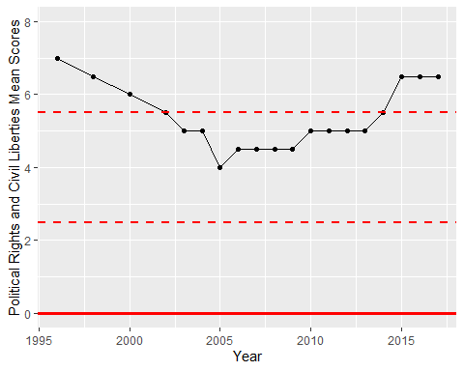

Freedom House Score Trend